If the G-code we provided does not apply to your hot bed, you can modify it as follows.

Take 310*310mm size hotbed as example.

The distance between the leveling screws and the edge of the hot bed is 30mm as below figure shown.
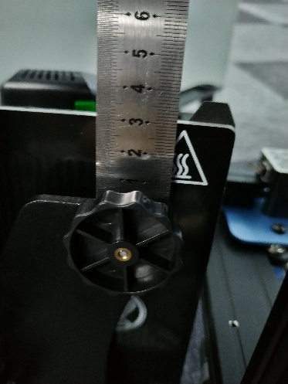

Open any of the G-code files we provide.
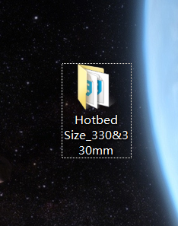

Edit the level gcode with Notepad.
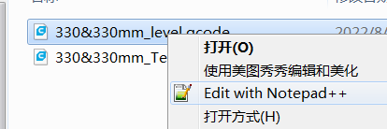

Change the values of the four points.
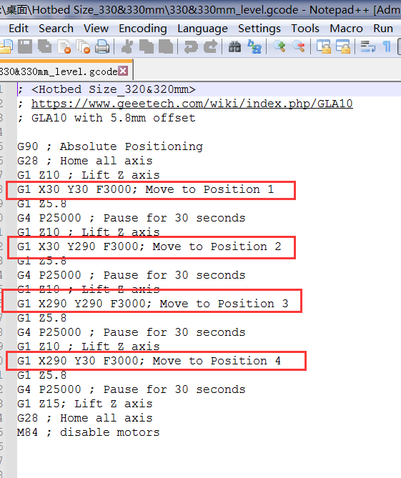

If your bed is 310*310mm size and the distance between the leveling screws and the edge of the bed is 30mm for example. The changes are shown below.
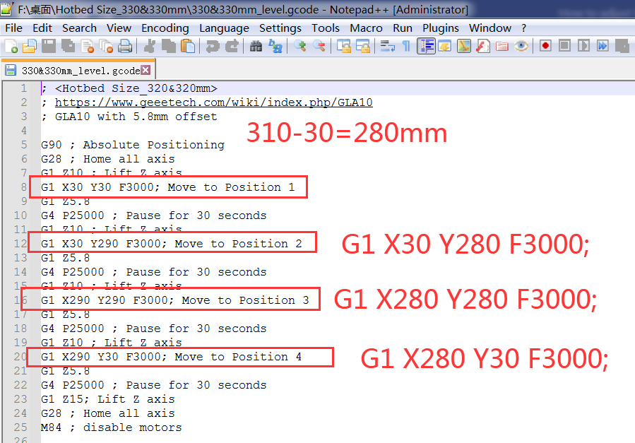

Save when you're done.
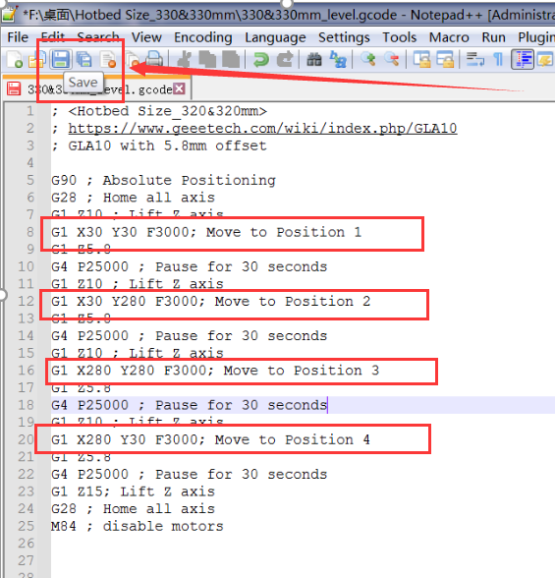

As for the test G-code, if it not suitable with your hotbed, we provide an STL file to you.
Download link:
https://www.geeetech.com/download.html?download_id=61

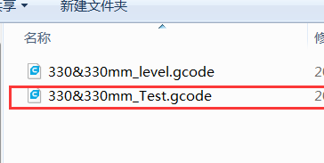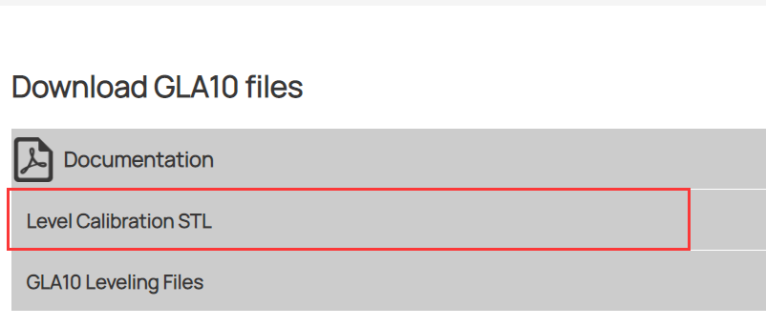

Adjust the scales as needed.
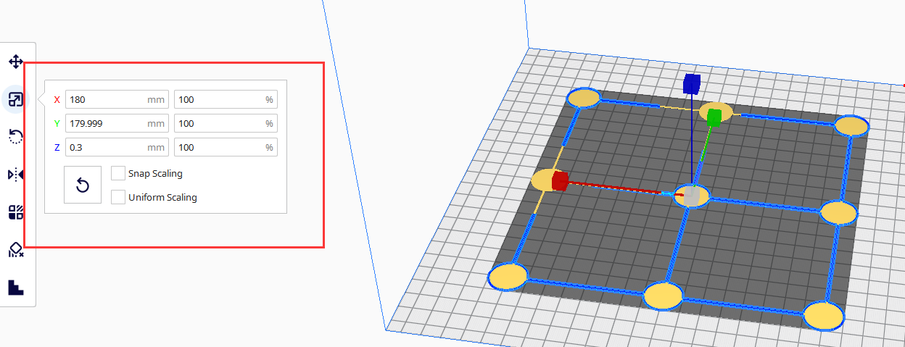

We recommend the settings as below.


